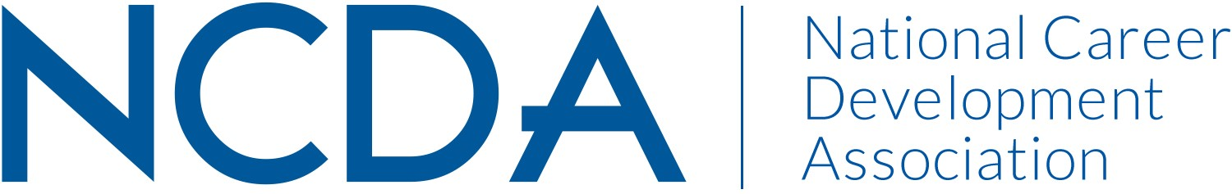

GOVERNMENT RELATIONS COMMITTEE
March 2025

Committee Leaership & Members

- Co-Chairs –
  - Elle O’Flaherty, elleoflaherty@interlacesolutions.com, 202-906-0618
  - Sarah JanTausch, sarah@valuesbasedcareers.com, 740-203-9054

- Committee Members - Natalie Kauffman, Lana Kaye Farley, Steve Myers, Sherita Bryant, Patricia Ferguson, Margi Williams, Steven D. Thomas, Saecilia Jackson, Ann Dawson, Diana Bailey, Eugenie Lewis
- Board Liaison - Carolyn Jones
- ACA Contacts - Guila Todd & Caitlin Flanagan

Activities to Date

Strategic Planning
- Completed Policy Workstream process development to codify process for identifying and advocating for critical legislation and regulations. See Policy Workstream Plan 2024-2025.
- Completed Guidance Document for policy projects to create a checklist for carrying out and finishing policy projects. See Guidance Document: Step-by-Step Process for Policy Projects.
- Wrote Communication Strategy to guide the committee’s current communication work and to build out capabilities into the future. See Phased Approach for GR Committee to Communicate Campaign Activity and Updates.

Policy
- Held committee and Board overview and training on FiscalNote and VoterVoice tools to support advocacy work.
- Created User Guide for FiscalNote and VoterVoice to guide new and existing users through the tools. See User Guide for FiscalNote and VoterVoice.
- NCDA Policy Submissions
  - NCDA Comment on FR Doc#2024-29996
  - NCDA Skills Investment Act letter.

Member Services
- Held webinar on April 28, 2005, for all NCDA members on FiscalNote, VoterVoice, and how to advocate in their own chapters and individually.
- Sent NCDA Government Relations Survey Assessing the Impact of Recent Executive Orders on NCDA Members to direct advocacy efforts and collect stories to share with congressional offices.
- Developed and sent weekly reports on federal legislative and regulatory activity in the career development space.
- Developed and implementing weekly, state-specific reports to support state CDAs by providing state-level updates on state legislative and regulatory activity in the career development space.
- Developing widget for inclusion on the NCDA website to encourage easy grassroots advocacy at the Member level.
- Completed Board-Approved Campaign Initiatives to outline communication procedures about advocacy work to ensure that Members see the value the GRC and NCDA are delivering to them.

Projected Plan/Work Planned to be Completed through September 30.

- Conference Presentation – GR Committee to present on its work, future advocacy work, and to give a short training on advocacy during the 2025 NCDA Conference.
- Legislative Award – GR Committee to nominate and present the legislative award to the winner during the 2025 NCDA Conference.
- Continued Reporting – Weekly reports to committee members, the board, and interested members giving real time updates on federal legislation and regulations impacting issues under the NCDA policy platform.
- Policy Positions – GRC to identify draft legislation and regulations of interest, write policy comments, gain board approval, and submit official comments to policymakers.
- NCDA Website – GRC to continue work to add widgets to the NCDA website for real time updates and member advocacy outreach.
- Hill Day – GRC to plan and coordinate Hill Day including creating talking points, briefing books, training, and scheduling meetings with congressional offices.

