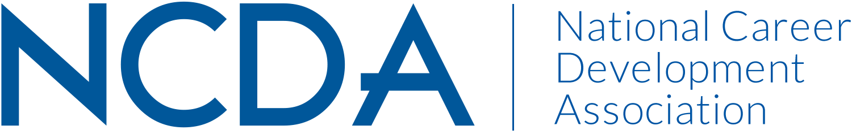

State Membership Recruitment Kit Order Form
Return form to: NCDA, 305 N. Beech Circle, Broken Arrow, OK 74012
FAX: 918-663-7058, Email: nscrimsher@ncda.org

NCDA has an exciting opportunity that will help your conference or event be successful – our membership recruitment kit. You are on the front line of our membership efforts, building and maintaining interest in career development at the state and local levels.

The kit contains:

- Two free NCDA publications to use as door prizes
- NCDA Publication Catalog
- NCDA Brochures
- NCDA Conference Materials (if available)
- Other NCDA materials such as name badge holders and conference bags (if available). Quantity needed depends on if available. Please advise if you are interested in these items, we will see if we can fulfill this request.

The kit is easy to use. Follow these three steps:

- Staff a table at your conference or event to provide information about your state association and to distribute NCDA material.
- Encourage attendees to fill out door prize entry cards.
- Hold a drawing and announce the winners.

Your support and enthusiasm make NCDA great! With your help, NCDA and your state association will be successful for many years to come.

Please fill out the information below. Please be very specific on how many you are expecting, that is how we monitor the materials sent.

We are expecting __________at our upcoming event. Date of Event: ______________________

Please send no later than (DATE) _________________.
Interested in name badge holders/conference bags. Circle please: Yes or No

Mail to: Name ___________________________________________________________________

Address: _________________________________________________________________

_________________________________________________________________

Phone: __________________________________________________________________

Conference or Event Title: _________________________________________________________

