National Career Development Association
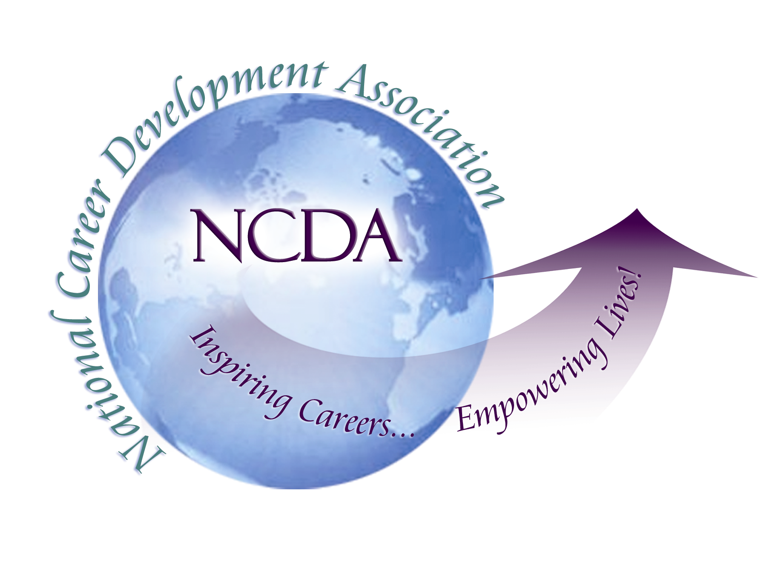
305 N. Beech Circle
Broken Arrow, OK 74012
918/663-7060
Fax: 918/663-7058
www.ncda.org

National Career Development Association
Leadership Academy
Action Learning Project Summary

Participant(s): Marty Apodaca

Board Mentor: Deb Osborn

Leadership Academy Class: 2017

Project Title: Exploring the need and delivery of distance career services.

Project Description: A survey was developed to measure NCDA participants’ thoughts and opinions on delivering distance career services (DCS) as well as the need for developing future trainings and best practices guidelines for DCS providers. The survey was sent to NCDA members and college career centers. The survey was brief and aimed at seeking insight from participants who provide DCS.

The initial question asked if participants currently provided DCS. If the participants responded “Yes,” the survey continued. If participants responded “No,” then the survey ended and one final question was asked. The final question for participants who did not provide DCS was whether they would be interested in a NCDA sponsored training for DCS providers. The scope of this question was to gauge participants’ interest in future NCDA sponsored trainings. A similar question was asked at the end of the survey for participants who provided DCS. Ideally the responses would show a need for NCDA sponsored trainings of DCS. If the need was high enough, the next goal of the project was to create a training for NCDA members in the form of a PDI or conference presentation that introduced participants to the basics of providing DCS. The proposed presentation would take place at the annual 2018 or 2019 NCDA conference.

The survey was comprised of three yes or no questions. An area of focus for these questions was to identify DCS providers from non-providers. A plan to evaluate DCS providers and participation in NCDA webinars was established, as well as evaluating a need for NCDA sponsored DCS training.

Three check all that apply questions were included to assist in identifying the credentials of DCS providers. These questions would explore what kind of services were offered by DCS providers. To build an effective follow up training for NCDA participants, a question was asked that explored possible venues, both online and in person, for hosting the event. Seeking to find out whether people who provided DCS preferred online training options would have been explored.

A survey matrix with 14 areas asked participants to rank their knowledge and skills on a variety of topics including referrals for clients who needed additional services, working with clients who had mental health issues, and ethical standards for delivery of services. Having participants rank their knowledge and skill set would allow us to explore possible topics to offer training on. The question also sought to find out how providers handled potential technical issues while delivering DCS.

Four opened-ended questions were asked that allowed participants an opportunity to openly share thoughts and ideas in regards to DCS. The questions also permitted participants to specifically identify areas of support NCDA could offer to DCS providers.

Summary/Conclusion:
Although the results of the survey were inconclusive, several authors have stated a need for distance career counseling and training (Dajali & Malone, 2004, Malone, n.d., Willie, 2014). The aim of the survey was to demonstrate a need for training amongst NCDA members. Once the need was identified, collaboration would occur to offer training in the form of a workshop, PDI, webinar, or online resource guide

However, I would like to proceed in offering a training for NCDA participants at a future NCDA conference. I feel there are many areas to cover in regards to training on the various aspects of DCS. Networking with local New Mexican career practitioners uncovered an interest in DCS. A workshop or training could be beneficial for NCDA members who reside in rural areas where clients may not have access to competent career practitioners. DCS training could also be beneficial to college campus career practitioners who work with a large commuter population or non-traditional students who work and are not on campus when the career center is open.

Results/Recommendations:
- Implementing a training for NCDA members on DCS.
- Developing a common set of NCDA suggested guidelines for coach/advisor/GCDF DCS providers and career/mental health DCS providers. I would then suggest a separate section for career/mental health licensed individuals that comply with state laws on DCS. The career/mental health section would address resources, referrals, and suggestions/strategies for working with clients concerning mental health issues.
- There are a multitude of potential training areas to address in regards to DCS. Workshops, webinars, and PDI’s could be implemented on:
  - Ethical considerations around providing DCS
  - Individual training topics specific to DCS
  - Exploration/training around different online platforms for delivering DCS
  - Common occurring issues and potential solutions while delivering DCS
  - Working with mental health issues while providing DCS
- Partnering up with the different NCDA committees to provide DCS trainings in regards to their specific areas

